## Creating a Semester Test Category

1. Choose “***Term 2***” from the Term Drop down list. 2. Choose “Semester Test” from the Task drop down list.

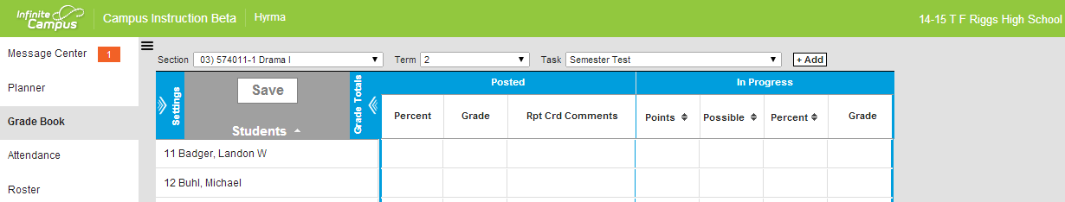

3. Click on the “***Settings***” expansion arrows: which gives you this dialog box:

|  |  |
| --- | --- |
|  | 4. Click on the “Categories” menu  . |
|  | This action will give you a list of the categories that you created for 1st and 2nd or 3rd and 4th quarters  5. Click the “***Add”*** button. |
|  | Create a new Category called  “Semester Test”  Leave the weight and the sequence as is  Under Category Placement  6. choose all the sections by clicking the box next to Term (or click each box individually)  Scroll down as you need to  Under Grading Task  7. Click Semester Test  8. Click the “Save” button |

## Creating a Semester Test Assignment

1. Click the “***Add***” button.



|  |  |
| --- | --- |
|  | Fill in the  Name,  Abbreviation and  Dates  Then scroll down to Scoring Alignment Detail. |
|  | Select “Semester Test” as the Grading Task.  Enter the number of total points |
|  | You can add description, objectives and references here  Click on the “***Save***” button |

## Copying Semester Test Category to other classes:

1. Click on the “***Settings***” expansion arrows: which gives you this dialog box:

|  |  |  |
| --- | --- | --- |
|  | 2. Click on the “Category Copier” menu  . | |
|  | | That will give you a screen that looks like the one on the left:  3. From the “Copy from” menu (on the left )choose a class that has the Semester Test Category that you just created.  Be sure to “unclick” the box in front of the categories that you don’t wish to copy  4. From the “Copy to” menu (On the right side) – choose the class that you would like to copy it to. (the categories that exist in that class will be listed below  5. Click the “”Next” button |

6. Click the “Copy” button.

